LANDSCAPE CHARACTER ASSESSMENT
LEVEL 1 & LEVEL 2 MAPPING – LEBANON
SUMMARY
Landscape is “an area as perceived by people, whose character is the result of the action and interaction of natural and/or human factors” (European Landscape Convention 2000).
With the different mountains, valleys, and coastal plains, Lebanon is known to be a country of contrasts. The Medscapes Project has proven through specific approach including desk research, field validation, and mapping that Lebanon is a country of diverse Landscapes. The results below of the Landscape Character Assessment in Lebanon are a basic tool for planning, decision making, and conservation on all levels from local to national level.

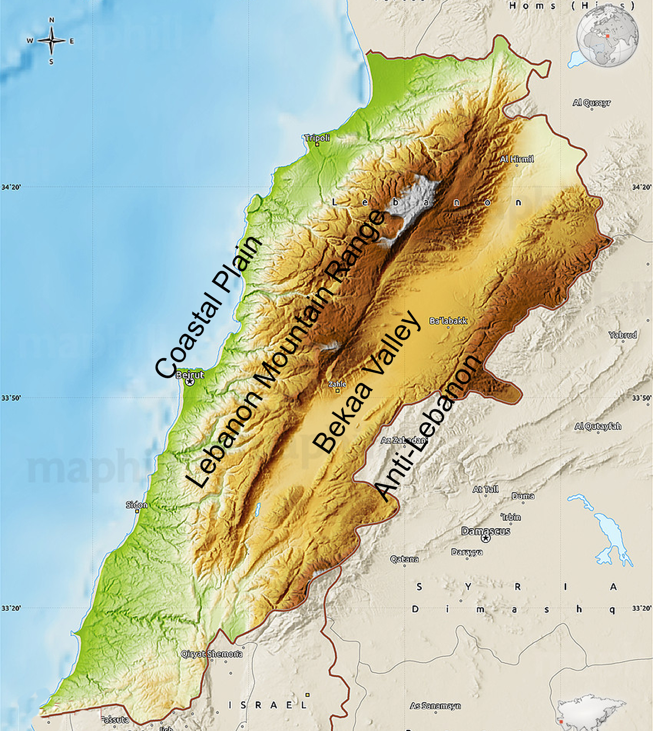
LEBANON
GEOMORPHOLOGY
Bordered by Syria to the North and East and Palestine to the South, Lebanon is located in the Eastern Mediterranean region and has an area of 10,452 square kilometers. Lebanon has a coastline that stretches 225 kilometers. It is divided into four distinct geomorphological regions:

Coastal plain: The coastal plain is relatively flat and is mainly inhabited
Lebanon mountain range: The mountain range extends along the entire country and stretches along 170 km parallel to the Mediterranean coast. It averages above 2,500 meters in elevation.
Bekaa valley: The valley is situated between Mount Lebanon to the West, and Anti-Lebanon mountains to the East. It is about 120 kilometers in length and has an average width of approximately 16 kilometers.
Anti Lebanon Mountains: It is a Southwest-Northeast trending mountain range that forms the majority of the border between Syria and Lebanon.

GEOLOGY
The fertile coastal plain is formed of marine sediments and river deposited alluvial material that rest on sandy and rocky beaches. As for the Lebanese mountains, they are formed of limestone and sandstone and is composed of narrow and deep gorges. The Bekaa valley is part of the Great Rift Valley system and is characterized by fertile soil of alluvial deposits. The mountains receive torrential rain that drains into the Bekaa valley and empties into the Mediterranean Sea. Lebanon contains sixteen rivers, many of which are seasonal rivers that dry out in the summer season.
CLIMATE
Lebanon typically has a Mediterranean climate where winters are generally cool and rainy while summers are humid and hot on the coastal stretch. At higher elevations, temperatures drop below zero in the winter and are characterized by heavy snow cover on higher mountaintops, while summers are humid in the day yet chilly at night. Lebanon receives a relatively high amount of precipitation compared to its arid surroundings, however areas that are obstructed by mountain chains and high peaks, such as the Bekaa valley, receive less annual precipitation.
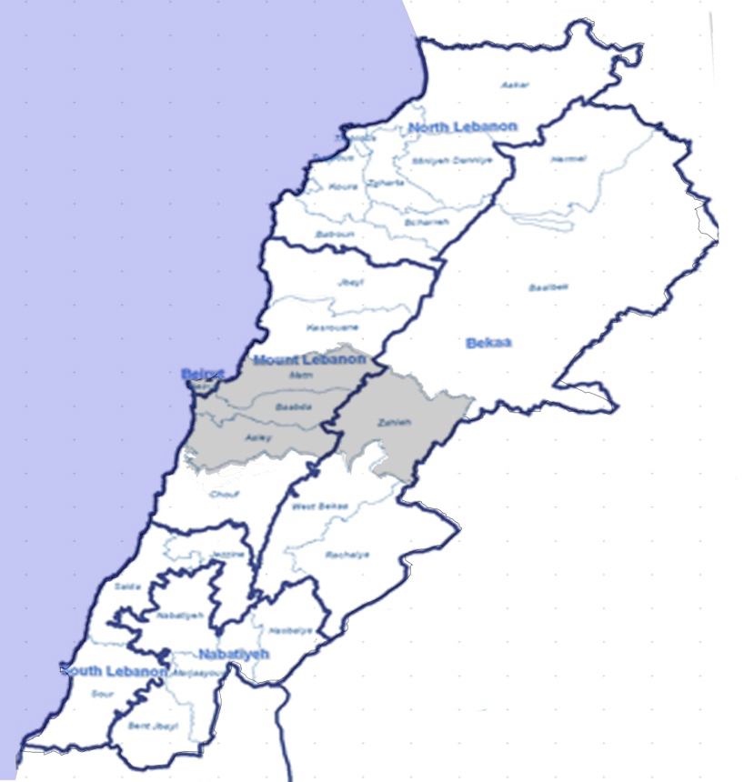
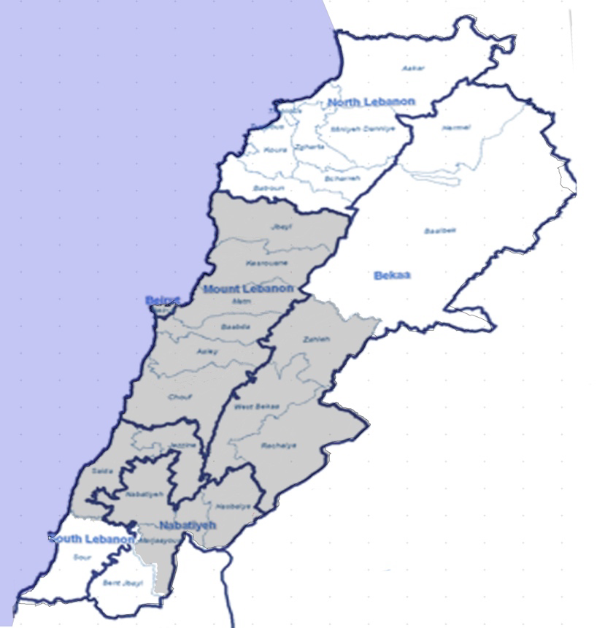
STUDY AREAS
LEVEL 1
The map on the right shows the highlighted study area for the MedScapes project in Lebanon that was subjected to a Landscape Character Assessment (LCA) at a scale of 1:250,000. The study area, which is representative of the four distinct geomorphological regions, contains 15 cazas and is 4747.40 Km², which is 45 % of the total area of Lebanon.
LEVEL 2
A transect was chosen to represent the four distinct geomorphological regions of Lebanon, at which the LCA was conducted at a finer scale of 1:50,000.

WHAT IS LANDSCAPE CHARACTER ASSESMENT (LCA)?
LCA is concerned with both urban and rural landscapes. It’s designed to be a decision making tool to help understand the landscape as it is today, how it came to be like that, and how it may change in the future. LCA provides the spatial framework within which to develop an integrated approach to landscape planning/land management (Warnock & Griffiths, 2014). A key component of the character-based approach to rural decision-making is the use of Geographical Information System (GIS). The LCA process began with desktop mapping, followed by fieldwork mapping, fieldwork validation utilizing remote sensing & mentoring by experts, and finally landscape character type classification and description.

DESKTOP MAPPING
Desktop mapping was step one in the assessment, it consists of gathering raw GIS data, and reclassifying & overlaying it in order to create a map with landscape description units. Landscape Descriptive Units (LDUs), were derived, which are distinct and homogenous units of land, each defined by a series of attributes; landform, ground type, landuse, and settlement, at level 1 assessment, at 1:250,000; and by 4 additional attributes at level 2 assessment, at 1:50,000: field patterns, species association, ecological integrity, and cultural integrity.
The outcome of the desktop mapping resulted in a preliminary map at level 1 consisting of 89 LDUs, and 158 LDUs at level 2, which would later be verified by fieldwork.
FIELDWORK MAPPING
Fieldwork mapping is then carried out in order to validate all the information in the desktop mapping. The first step was to hold a training seminar for the fieldworkers in order to acquire techniques of field surveying and be familiar with the process of on site mapping. The fieldworkers filled field survey forms and used field equipment to validate the desktop mapping through GIS. The primary function of the field survey is to observe the characteristics that contribute to local distinctiveness, verify the content of the LDU as compared to the maps, amend boundaries of the units, complete a field assessment for each unit, as well as carry out a photographic survey.
The field teams met on a weekly basis in order to compile information, coordinate, and assure that all teams are working in a coherent and systematic way.

FIELDWORK VALIDATION
Validation of the work conducted on the field was carried out by the fieldwork team & mentors who guided the process of utilizing remote sensing to amend boundaries of the LDUs.

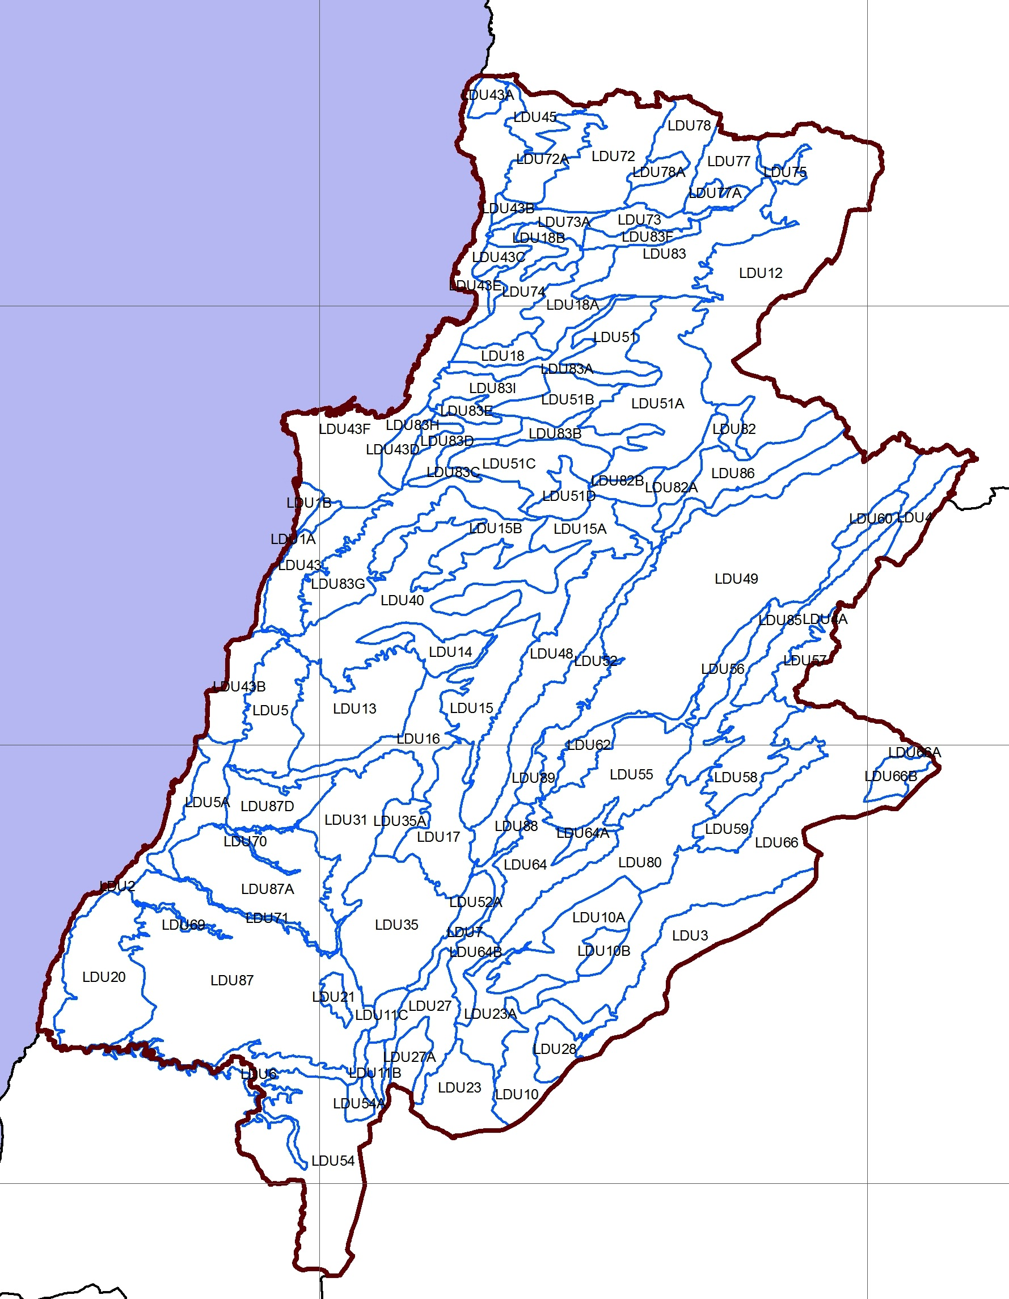
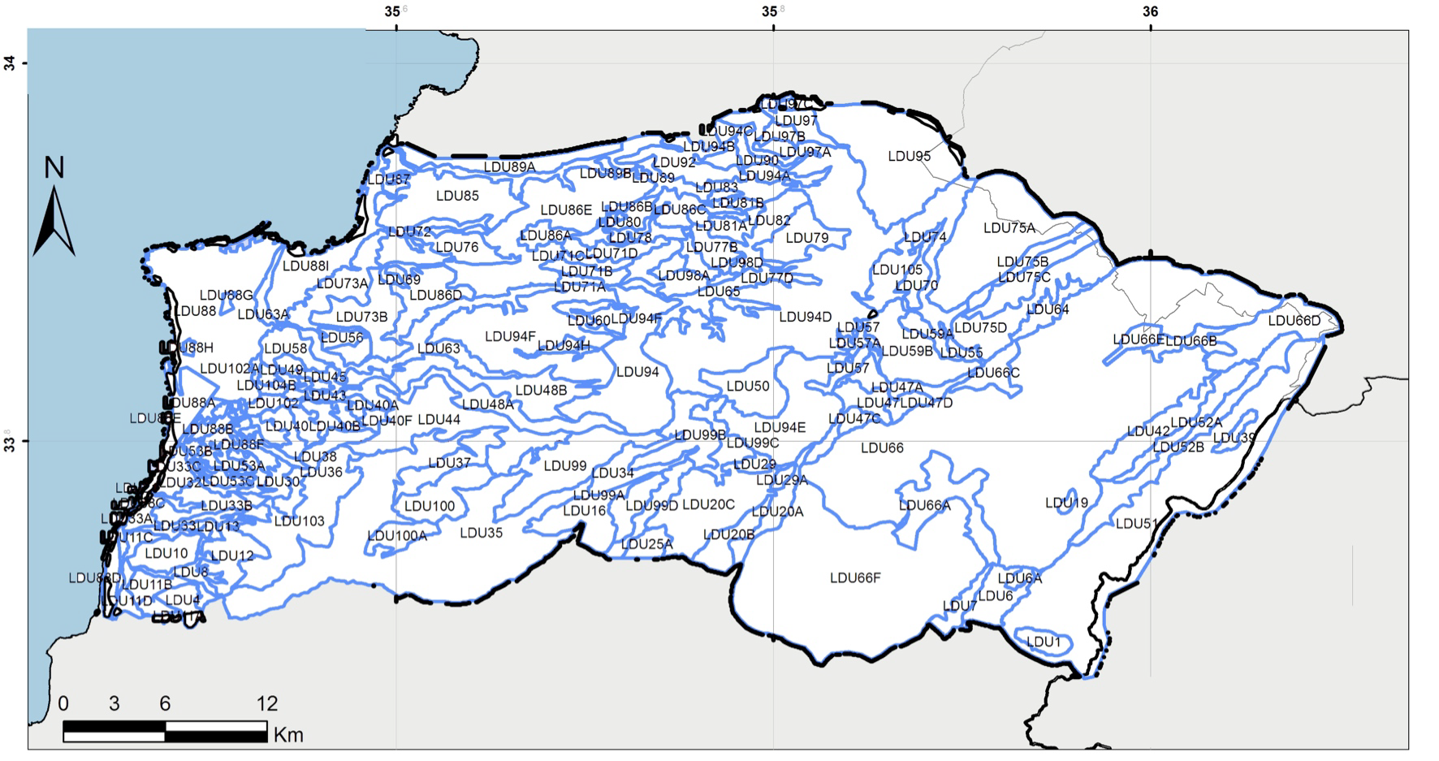
RESULTANT MAPS
LEVEL 1 LEVEL 2

102 final LDUs 162 final LDUs

LCT CLASSIFICATION AND DESCRIPTION
The process of LDU mapping gives a complete ‘birds eye’ view of the land, which in turn provides a structured spatial framework for gathering additional descriptive information about the visual dimension of the landscape and values by people on the ground. By contrast to the mapping of LDUs, the derivation of Landscape Character Types (LCTs) recognizes the human perception of prominent visual characteristics and/or locally distinctive features. For this reason, LCTs are defined by grouping together LDUs with the same prominent visual characteristics and thus the LDUs had to be categorized into groups sharing same characteristics in order to come up with the final landscape character map.

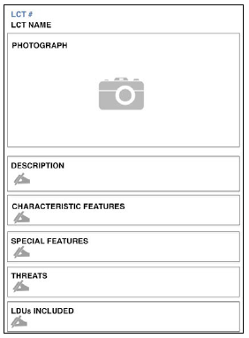
A sheet was filled out for each LCT,
following the format here:

Due to the diversity of entries of the 4 attributes assessed at level 1 & 8 attributes assessed at level 2, a compromise had to be made to group the LDUs into character types, and 2 attributes were mostly focused on to derive the final LCTs: Landform and land use. The names of the LCTs reflect landform, landuse, and settlement type, yielding a Landscape Character Type map.

LEVEL 1
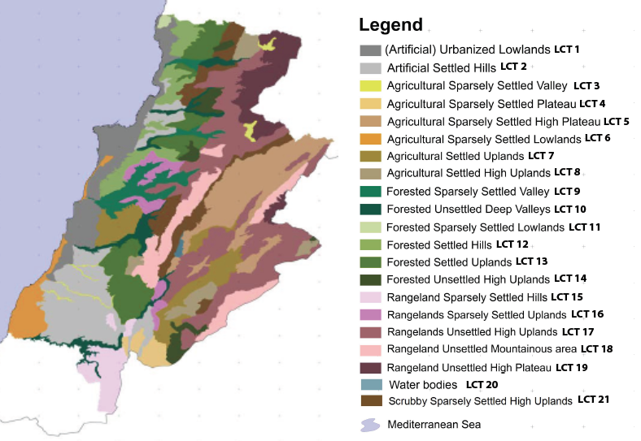
21 LCTs

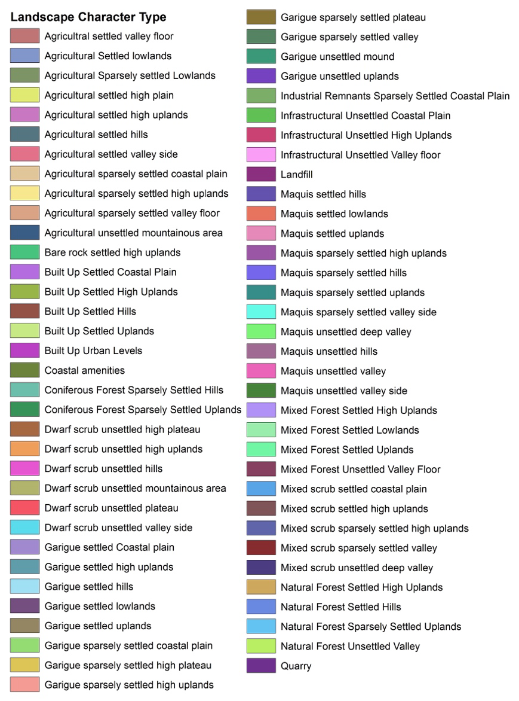
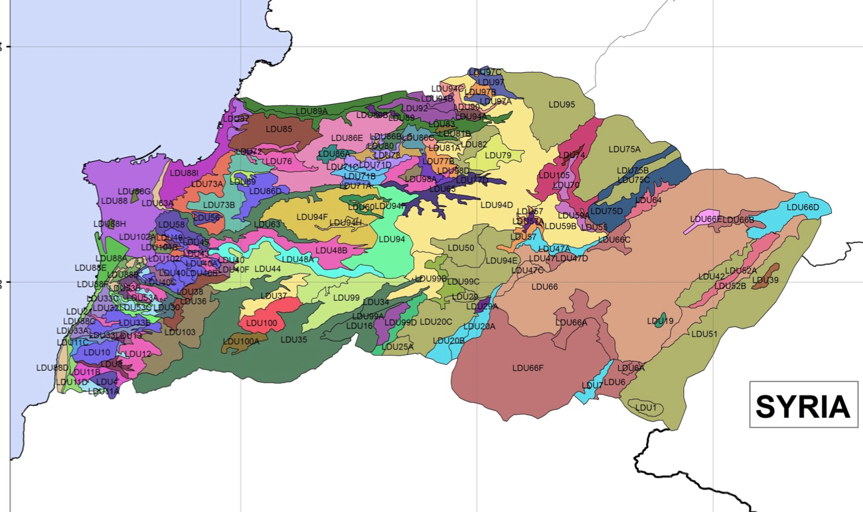
LEVEL 2
68 LCTs

